Before Middle After Activity- 1950s

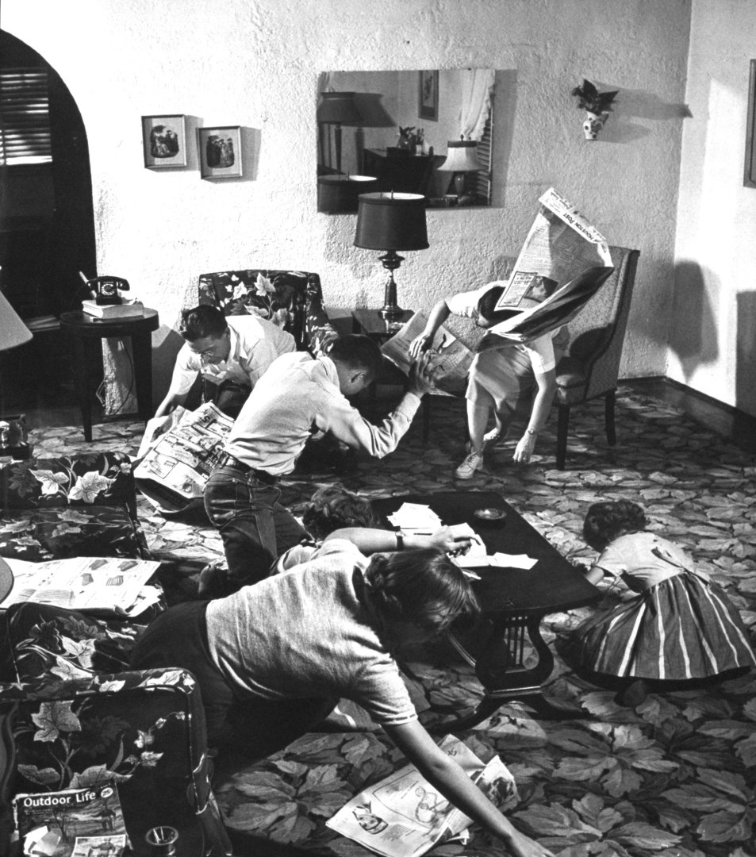

Directions: Write a full page (entire front for credit) describing events that occurred before this image, during this image, and after this image.
To get “A” credit you must use at least 5 specific references to event, items, or people you have covered in the Early Cold War Period. “C” credit 2 events, items, or people.

Please number the items you want me to consider for credit at the end of the sentence.

Please write in complete sentences.

